How to use AU and updates

Put pattern into the AU update address:

Ex: C:\activeupdate\pattern\ Url00000.367.zip

C:\activeupdate\pattern\ Url00000.367.sig

Put server.ini in the C:\activeupdate\server.ini

Put pattern in the \activeupdate\pattern\ ZETA_DPI_1080.zip and Url00000.367.zip

Configuration of server.ini ex:

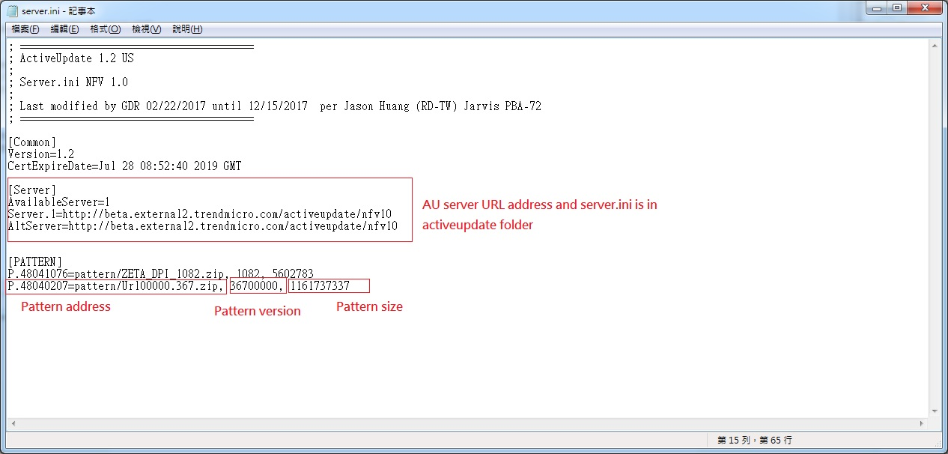

EMS update function

1. Configure AU server at page Administration > Updates > Update Source> other update source

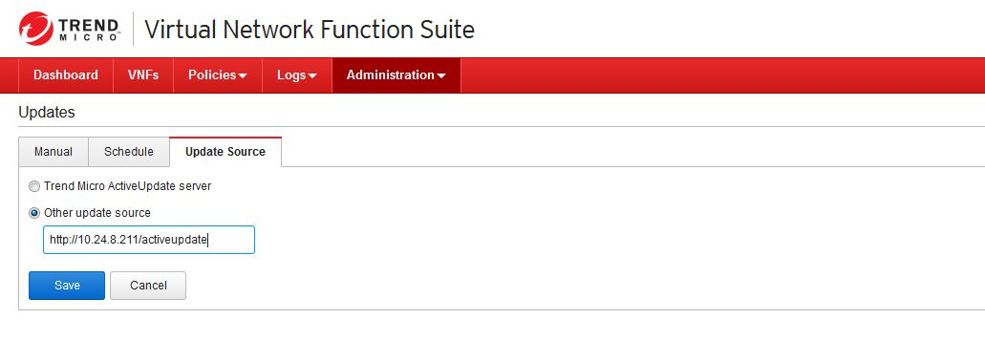

1. Modified AU update time per hour or day or week.

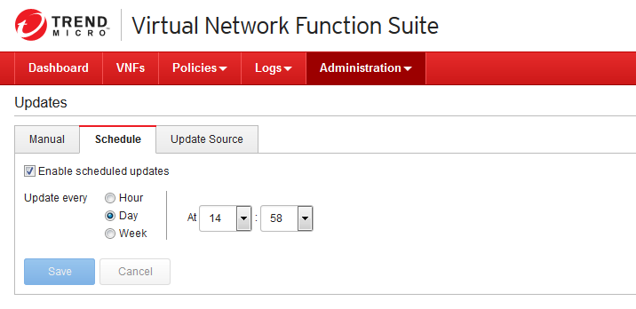

1. Check version after update finished.

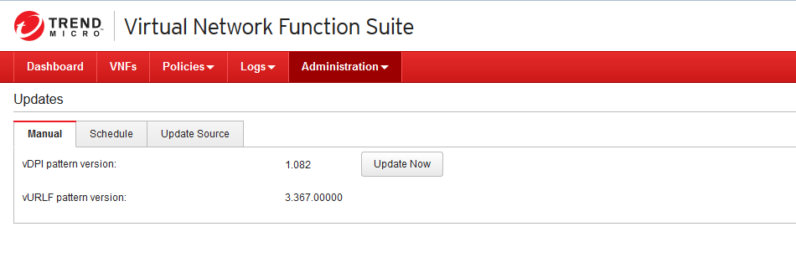

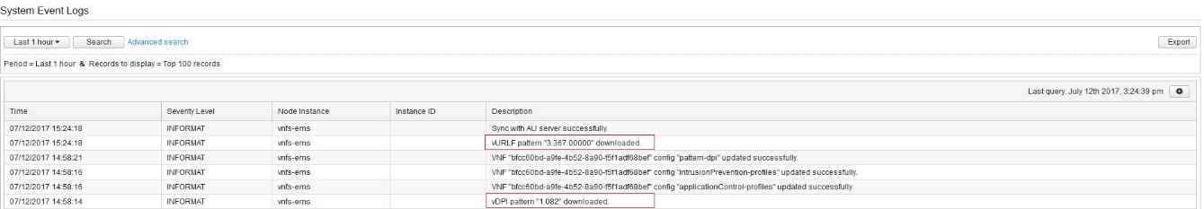

After EMS update success, modified settings for VNF use URL pattern.

1. VNF use URL pattern need to enable local database

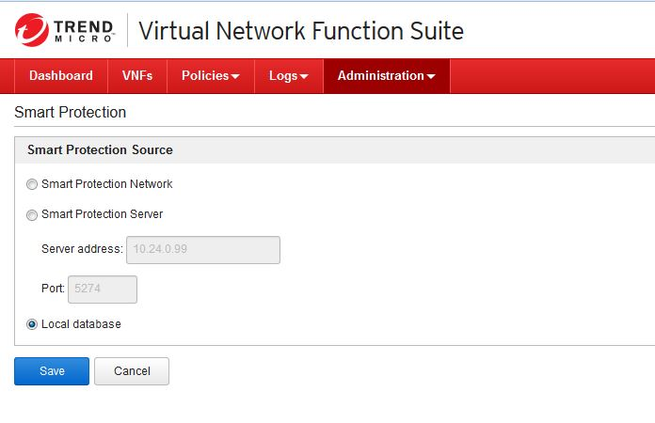

1. Check VNF version status

Original:

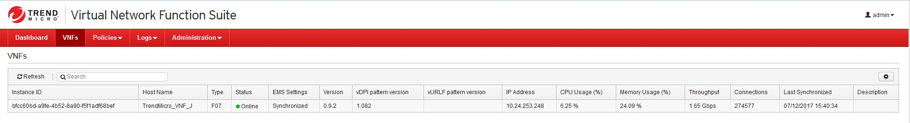

After update:

